

**Session : 2023 – 2024**

E-Learning Website

**A PROJECT REPORT**

**Submitted By**

Muskan ( 2115000638)

Riya Bansal( 2115000862 )

Vaishnavi Sharma ( 2115001086 )

Vivek Kumar(2115001145)

***partial fulfillment for the award of the degree of***

##### BACHELOR OF ENGINEERING

**IN**

Computer Engineering & Applications

( Institute of Engineering & Technology )

**GLA University, Mathura - 281406**

## BONAFIDE CERTIFICATE

This is to certify that the project entitled “ **E-Learning Website**”, carried out as Mini Project - I, is the bonafide work of “**Muskan , Riya Bansal, Vaishnavi Sharma,Vivek Kumar**” who carried out the project work under my supervision.

##### SIGNATURE SIGNATURE

Dr. Rohit Agrawal Ruchi Gupta

**HEAD OF THE DEPARTMENT SUPERVISOR**

Department of Computer Engineering Technical Trainer & Application (GLAU) (GLAU)

## ACKNOWLEDGEMENT

We would like to express our deep sense of gratitude and respect towards **Ruchi Gupta**, Technical Trainer, Computer Science & Engineering Department for guiding and encouraging us throughout the project.

Her sincerity and determination has been a constant source of inspiration for us. We also believe that she will empower us with all his great innovative ideas and different stages of the project. We would not like to miss the opportunity to thank and acknowledge the contribution of all the faculty members of the department for their kind guidance and co-operation.

##### Muskan ( 2115000638 )

##### Riya Bansal ( 2115000862 )

##### Vaishnavi Sharma ( 2115001086 )

##### Vivek Kumar(2115001145)

**Abstract**

## TABLE OF CONTENTS

**Abbreviations**

**Chapter 1. Introduction**

* 1. Overview
  2. Background Study
  3. Project Planning
  4. Timeline
  5. Organization of Report

**Chapter 2. Goals and Objectives**

* 1. Problem Statement
  2. Goals and Objective

**Chapter 3. Design Flow**

* 1. Hardware & Software Requirements
  2. Project Design

**Chapter 4. Technologies**

**Chapter 5. Conclusion Chapter 6. Future Work**

**References**

## ABSTRACT

The objective of this website will Enhance the quality of learning and teaching. Meet the learning style or needs of students. Improve the efficiency and effectiveness. Improve user-accessibility and time flexibility to engage learners in the learning process.

Our E-learning website is **Insighters** that will help you to learn online. And access free courses from our website.

we believe that everyone must be equipped with basic knowledge in Technology, as well as use it as a medium to reach a particular goal and aim. In the 20th century, we have moved from the Industrial Age through the Information Age and now to the Knowledge Age. Knowledge and its efficient management constitute the key to success and survival for organizations in the highly dynamic and competitive world of today. Efficient acquisition, storage, transfer, retrieval, application, and visualization of knowledge often distinguish successful organizations from the

unsuccessful ones.

It helps students learn efficiently by gaining recourses and attending lectures online. It is deemed cheaper and reliable as student can learn and practice independently without pressure and stiff competition like real classrooms.

NO peer pressure in E-learning Like school, where the teachers and other student pressurize to score well, this website helps students focus on themselves and do better. When coopetition isn’t very stiff and healthy, student can concentrate more and make the most out of their study time.

Through Insighters you can learn course of your choice through online resources. Lower costs than conventional teaching approaches are provided at Insighters.

## ABREVIATIONS

|  |  |
| --- | --- |
| HTML | Hyper Text Markup Language |
| CSS | Cascading Style Sheet |
| JS | Java Script |
|  |  |

+

**Chapter – 1**

**Introduction**

**1.1 Overview**

E-learning is an education via the Internet, network, or standalone computer. E-learning is

basically the network- enabled convey of skills and knowledge. E-learning refers to using

electronic applications and processes to learn. E-learning includes all forms of electronically supported learning and teaching (Trikes, G,2010).

The information and communication systems, whether networked learning or not, serve as specific media to implement the learning process. This often involves both out-of-classroom and in-classroom educational experiences via technology, even as advances continue in regard to devicesand curriculum. E-learning is the computer and network-enabled transfer of skills and knowledge.

E-learning applications and processes include Web-based learning, computer-based learning, virtual education opportunities and digital collaboration. Content is delivered via the Internet,intranet/extranet, audio or video tape, satellite TV, and CD-ROM. That is to say E-learning systems contain both Learning Management System and Course management system. It can be self-pace or instructor-led and includes media in the form of text, image, animation, streaming video and audio. It is commonly thought that new technologies can make a big difference in education. In young ages especially, children can use the huge interactivity of new media, and develop their skills, knowledge, and perception of the world, under their parents' monitoring, of course.

With the increasing adoption of the Internet and rise in awareness about e-learning, the online education industry is expected to witness promising growth during the forecast period. Ease of learning, flexibility, and a wide range of study materials have influenced the overall growth of the industry. The online education market is segmented into primary and secondary supplemental education, test preparation, reskilling and certification, higher education language, and casual learning. The change in consumer behavior towards detailed learning and surge in demand from tier II and tier III cities are driving the growth of this segment. The online test preparation market is expected to reach INR 94.75 Bn by 2024. This segment is expected to be the fastest-growing segment in the online education market.

E- Learning education is an electronically supported learning system, which relies on the Internet for interaction and distribution of course material between students and teachers. Growing demand to reduce the cost of education, increasing government initiatives supporting online education, and increasing penetration of smartphones and the Internet are the factors contributing to the growth of the global online education market. Additionally, the market is also expected to be boosted owing to the increasing demand for adaptive learning. However, the availability of abundant free content and lack of awareness is limiting the market growth.

Many proponents of e-learning believe that everyone must be equipped with basic knowledge InTechnology, as well as use it as a medium to reach a particular goal and aim. In the 20th century, we have moved from the Industrial Age through the Information Age and now to the Knowledge Age. Knowledge and its efficient management constitute the key to success and survival for organizations in the highly dynamic and competitive world of today. Efficient acquisition, storage, transfer, retrieval, application, and visualization of knowledge often distinguish successful organizations from the unsuccessful ones.

###### Project Planning

The project planning phase involves a meticulous and strategic approach to outline the goals, scope, and milestones of the Hotel Management Website development. This includes the identification of key project objectives, the definition of the project scope, the establishment of clear milestones, and the deployment of effective methodologies to ensure a systematic and organized execution. A detailed timeline is crafted to provide a roadmap for development, allowing for efficient tracking, monitoring, and management of the project throughout its lifecycle. This phase sets the foundation for a successful and well-coordinated implementation, aligning the project with its overarching goals and ensuring a streamlined path towards completion.

##### Timeline

|  |  |
| --- | --- |
| 06 Nov – 07 Nov | Requirement Specification, Built up Model |
| 08 Nov – 12 Nov | Designing of Website and User Interface |
| 13 Nov – 25 Nov | Implementation started. Started building website. |
| 26 Nov | Completed Project. Testing. User Review. |
| 27 Nov – 4 Dec | Project Presentation and Report Submission. |

**Organization of Report**

Chapter 1 -Gives the introduction to the project specifying the need of the project, various problems which would be solved through the project and the various tasks required to be performed for completion of the project. It also tells the timeline of various activities performed.

Chapter 2 -Specifies the problem statement and the goals and objectives of the project.

Chapter 3 -Gives details about the model and design of the project. Various constraints are also discussed here. It gives the structure of the website. It provides all the details about each section provided in the website.

Chapter 4- Talks about how the design is implemented using various technologies. Chapter 5 -Concludes the project and gives the future scope.

**Chapter-2**

## GOALS AND OBJECTIVES

E-Learning represents an innovative shift in the field of learning, providing rapid access to specific knowledge and information. It offers online instruction that can be delivered anytime and anywhere through a wide range of electronic learning solutions such as Web-based courseware, online discussion groups, live virtual classes, video and audio streaming, Web chat, online simulations, and virtual mentoring. E-Learning enables organizations to transcend distance and other organizational gaps by providing a cohesive virtual learning environment. Companies must educate and train vendors, employees, partners, and clients to stay competitive and E-Learning can provide such just-in-time training in a cost-effective way.

Developing and deploying effective E-Learning programs may require products and services supplied by a variety of vendors, leaving one to connect the dots. One way to start is to define the goals of the desired learning solution. Definition of the goals of an E-Learning solution is driven by the following factors:

* Attracting and recruiting new students.
* Promoting our excellence in teaching and research. Providing consistent, up-to-date
* information.
* Attracting and recruiting people to study here. Provide our best faculty to students.
* Simple, easy to use platform for student and parent engagement. Can create classrooms,
* add students, assign homework or activities.
* The Class Story feature helps parents remain updated on their child's progress and learning.
* Creates a competitive environment for students

**Chapter-3**

# DESIGN FLOW

**Hardware Requirements**

* Processor : i3
* Main Memory : 500mb
* Cache Memory : 512kb
* Monitor : 13.5 colour Monitor
* Keyboard
* Mouse

**Software Requirements**

* **System Software –**

**Operating System:** Windows 10

* **Application Software -**

Tools : GitHub, Vs Code, Xampp.

# Project Design

# The website has various sections-

**Login Page:-**

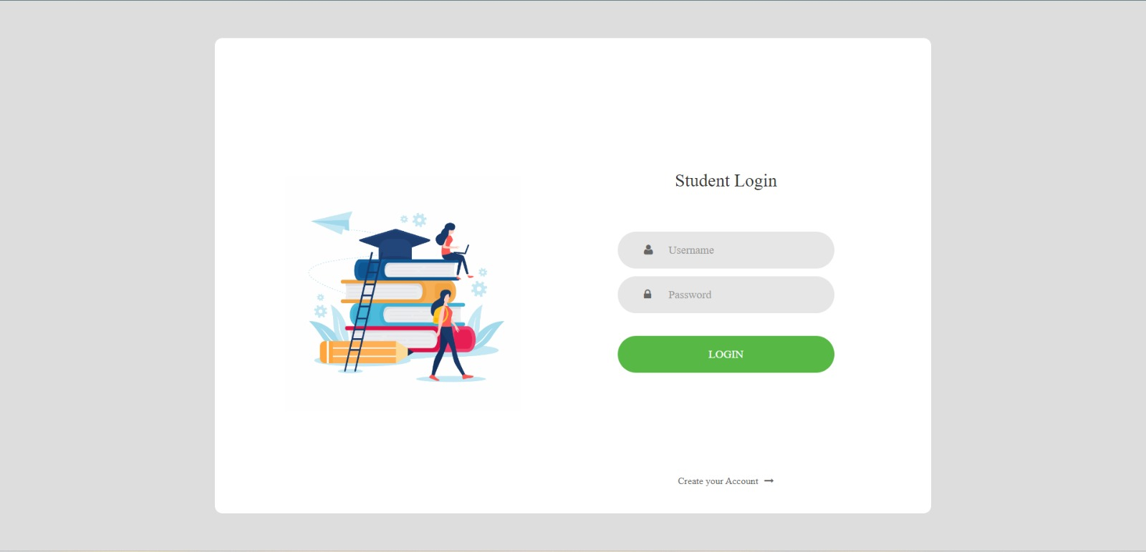

**Sign Up:-**

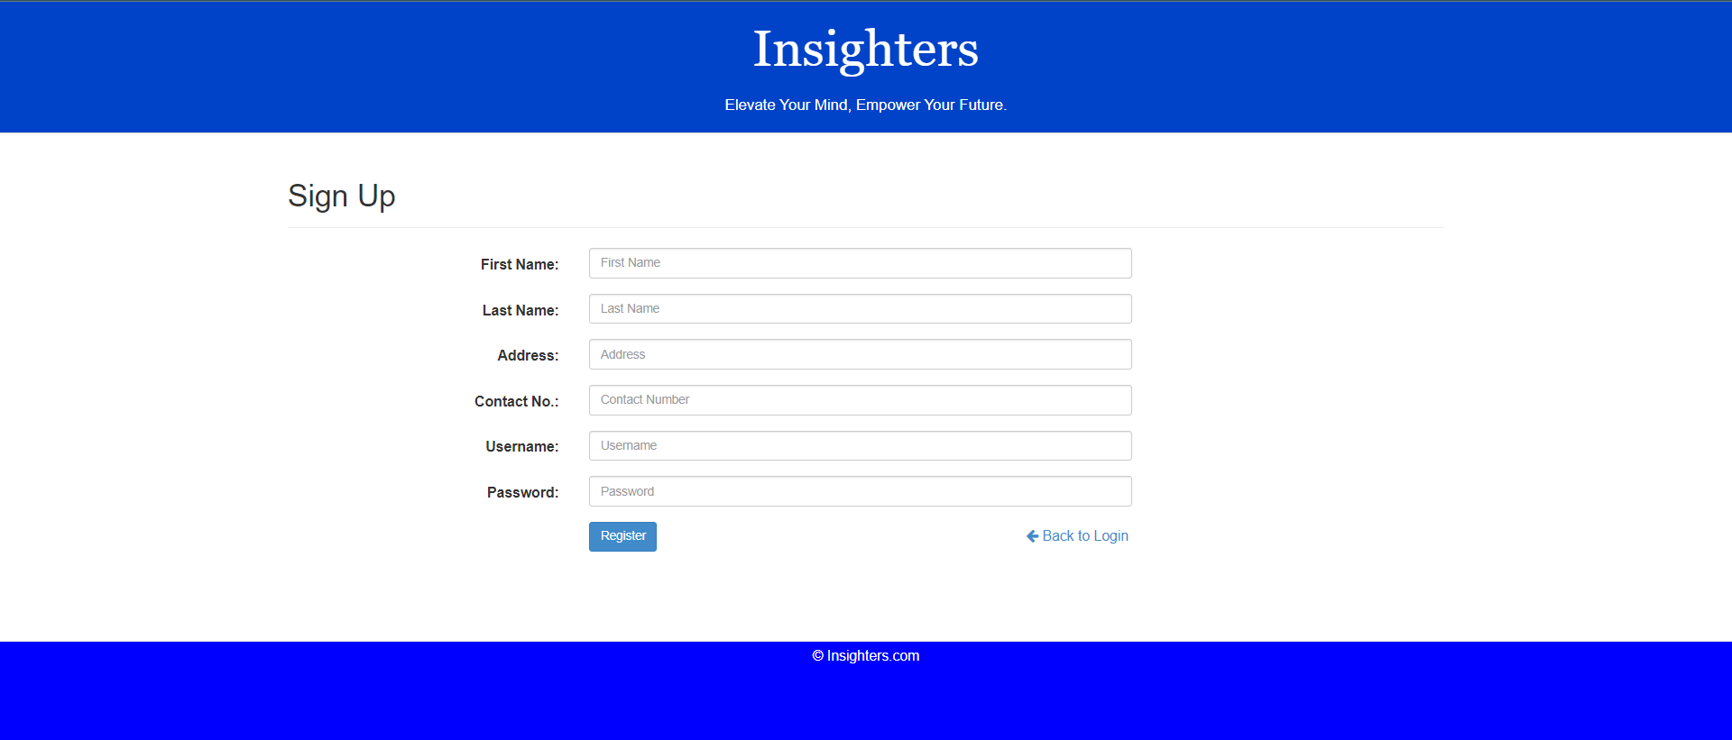

**Home page:-**

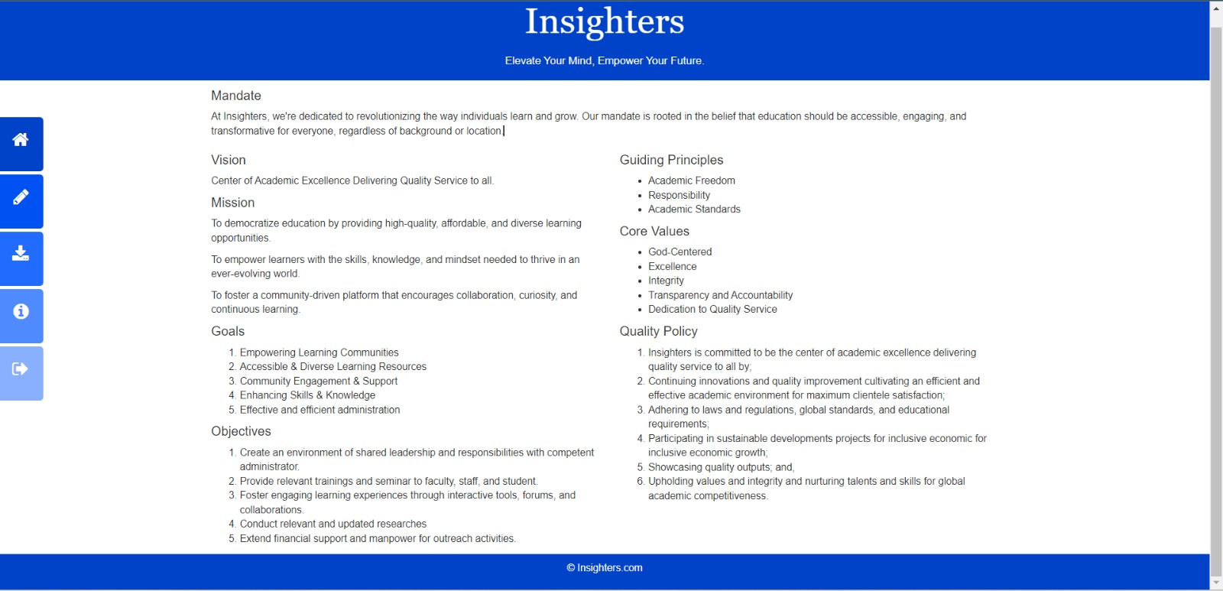

**Exercises Page:-**

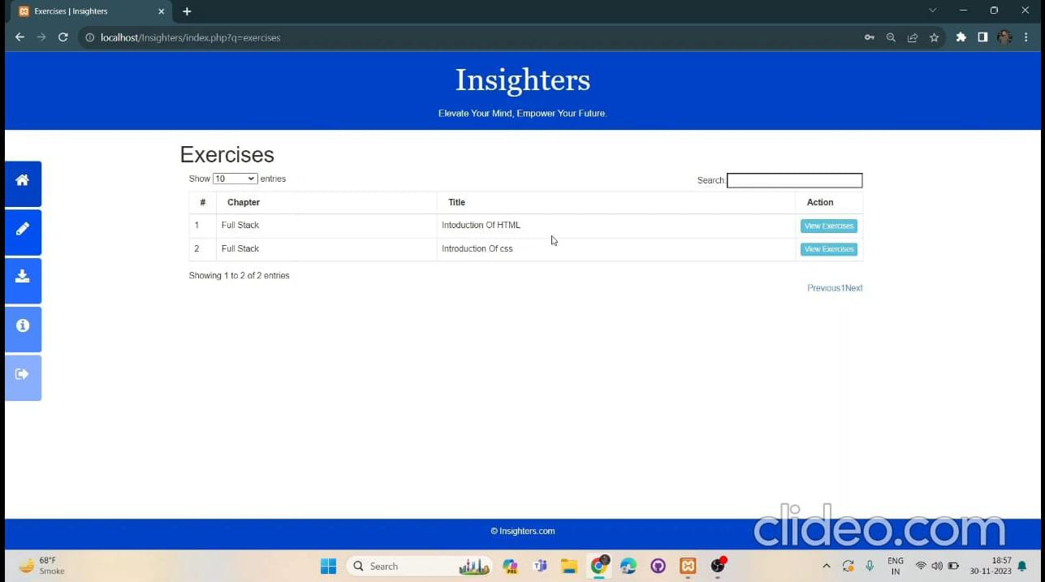

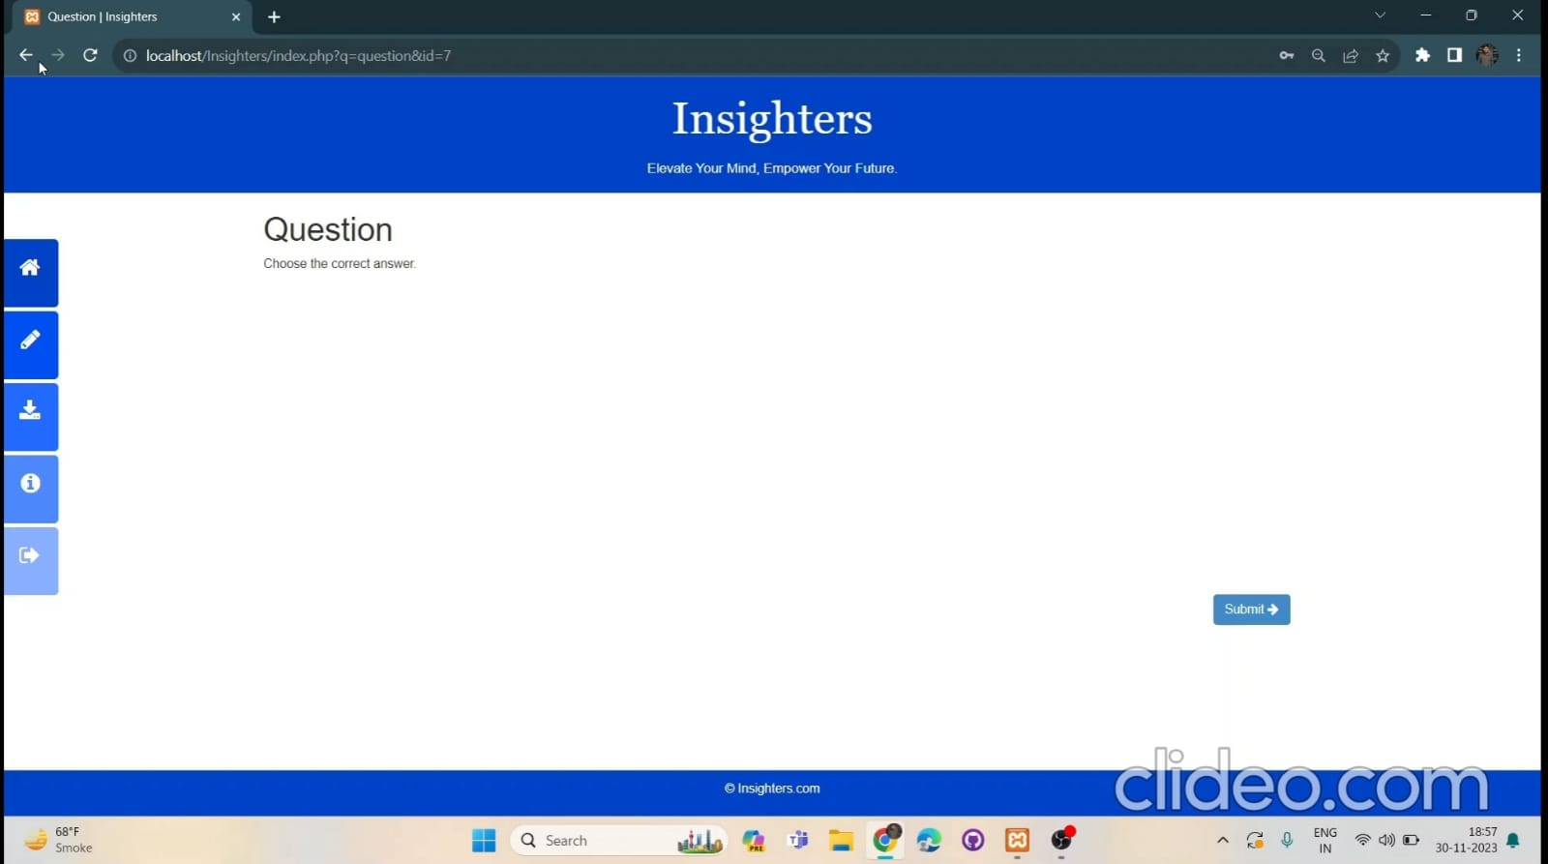

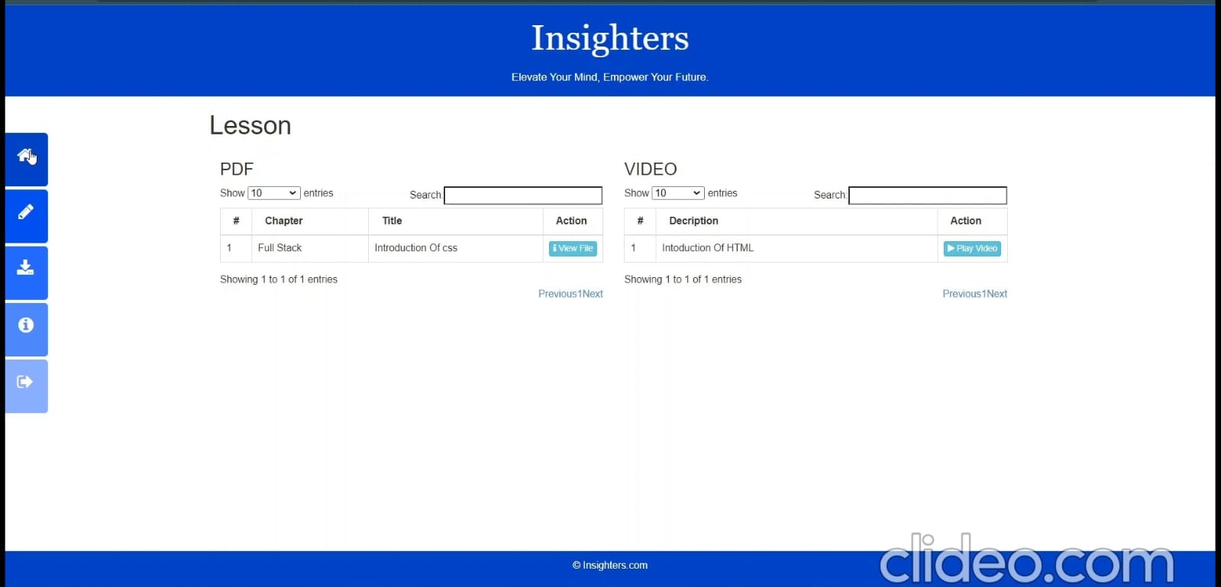

**About Us:-**

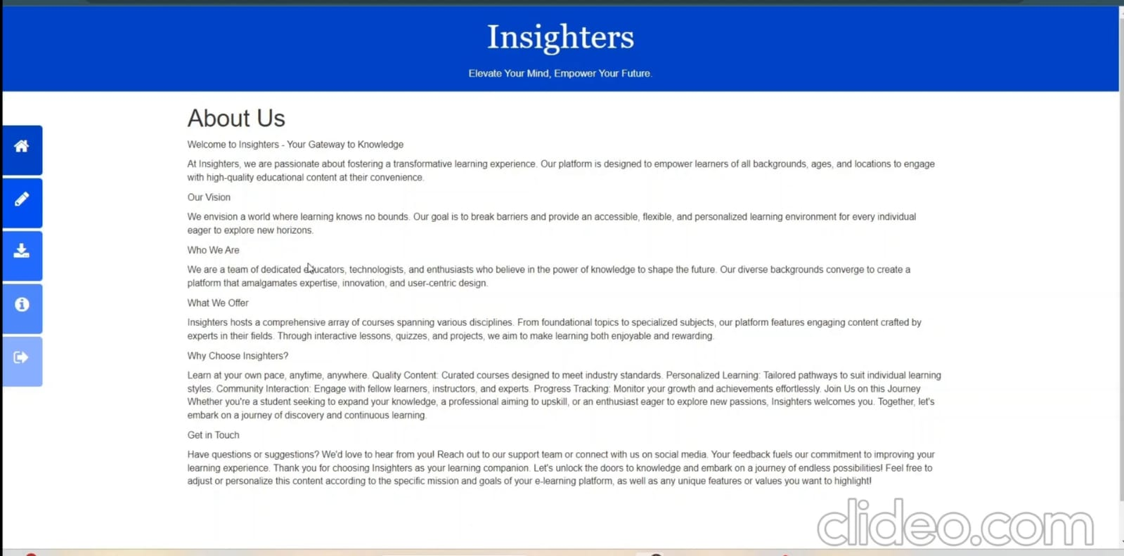

**Admin Interface:-**

**Login page-**

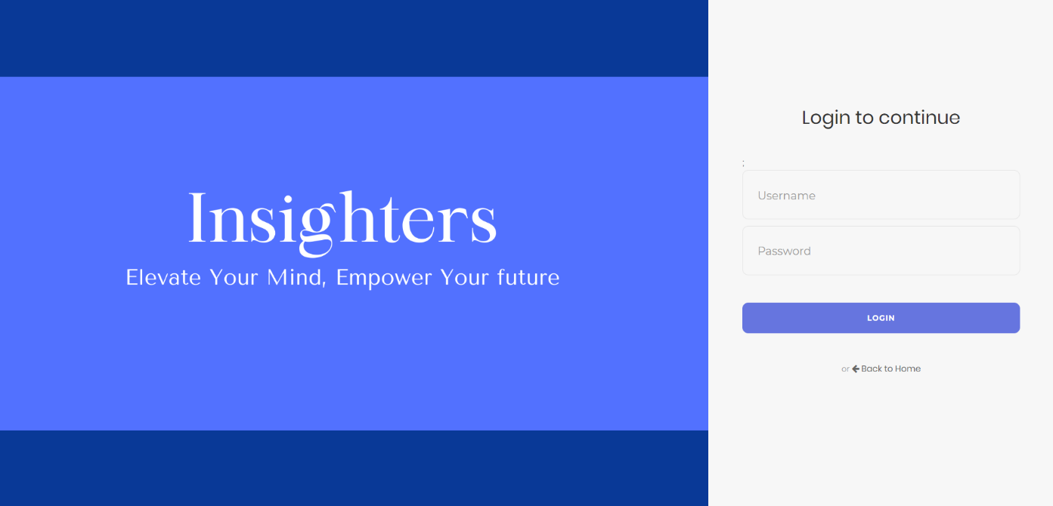

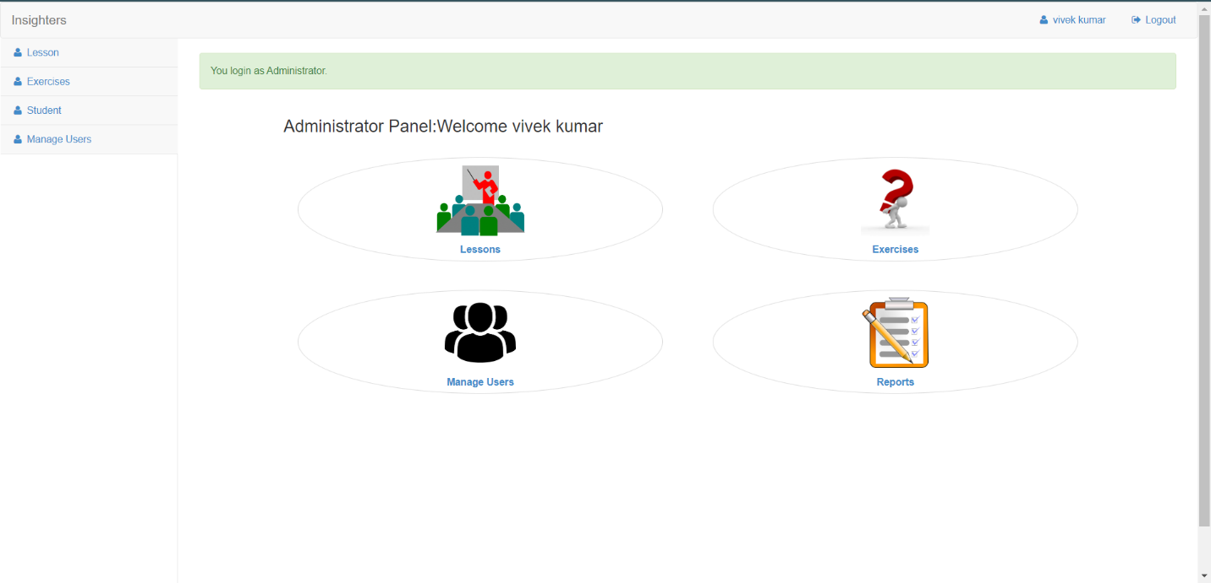

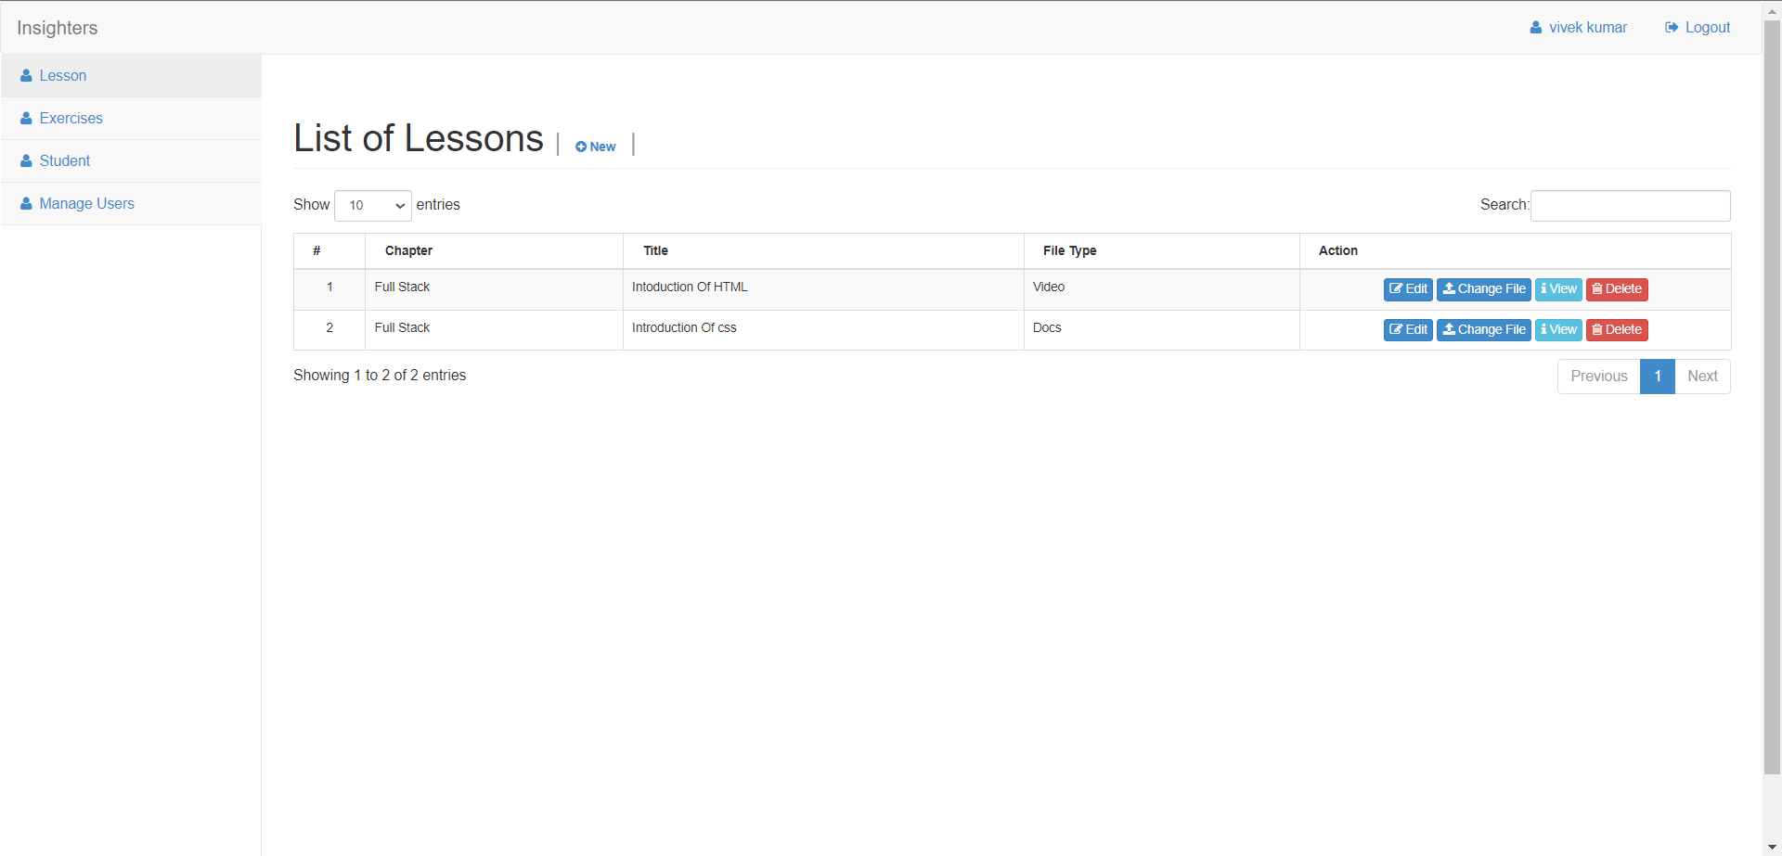

# Technologies

##### HTML(Hyper Text Markup Language):-

HTML (Hyper Text Markup Language) is the most basic building block of the Web. It defines the meaning and structure of web content. Other technologies besides HTML are generally used to describe a web page's appearance/presentation (CSS) or functionality/behavior (JavaScript).

##### CSS(Cascading Styling Sheet):-

Cascading Style Sheets (CSS) is a style sheet language used for describing the presentation of a document written in a markup language such as HTML . CSS is a cornerstone technology of the World Wide Web, alongside HTML and JavaScript. CSS is designed to enable the separation of content and presentation, including layout, colors, and fonts.

##### JavaScript :-

JavaScript is a programming language used primarily for creating interactive front-end web applications. It is one of the core technologies used for building modern web applications and is supported by all major web browsers. JavaScript is often used in conjunction with HTML and CSS to create rich, interactive web pages. It is a versatile language that can be used for a variety of purposes, including creating web applications, building mobile applications using frameworks such as React Native and Ionic, and developing server-side applications using Node.js.

**PHP:-**

PHP is an open-source, interpreted, and object-oriented scripting language that can be executed at the server-side. PHP is well suited for web development. Therefore, it is used to develop web applications . PHP is a server-side scripting language, which is used to design the dynamic web applications with MySQL database. o It handles dynamic content, database as well as session tracking for the website.

**MYSQL:-**

MySQL is an open-source relational database management system. As with other relational

databases, MySQL stores data in tables made up of rows and columns. Users can define,

manipulate, control, and query data using Structured Query Language, more commonly known as

SQL. MySQL’s name is a combination of “My,” the name of MySQL creator Michael Widenius’s daughter, and “SQL”. The data in a MySQL database are stored in tables. A table is a collection of related data, and it consists of columns and rows.

### Conclusion

It has been a great pleasure for me to work on this exciting and challenging project. This project proved good for me as it provided practical knowledge of not only in HTML, CSS and JavaScript web-based application and no some extent Windows Application and SQL Server, but also about backend language PHP. It also provides knowledge about the latest technology used in developing web enabled application. This will provide better opportunities and guidance in future in developing projects independently.

Finally, I would like to express myself as to how I find this process of developing a system to be very awaking to the mind of a student and to learn how to and teach themselves things. I have built a skill of how to search for things and develop then to my needs. It has indeed been a great experience

### Future work

In a nutshell, it can be summarized that the future scope of the project circles around maintaining information regarding:

* We can add printer in future.
* We can give more advance software for E-learning Management System including more facilities
* We will host the platform on online servers to make it accessible worldwide Integrate multiple load balancers to distribute the loads of the system
* Create the master and slave database structure to reduce the overload of the database queries
* Implement the backup mechanism for taking backup of codebase and database on regular basis on different servers

The above mentioned points are the enhancements which can be done to increase the applicability and usage of this project. Here we can maintain the records of Assignment and Student. Also, as it can be seen that now-a-days the players are versatile, i.e. so there is a scope for introducing a method to maintain the E-learning Management System. Enhancements can be done to maintain all the Assignment, Student, TEACHER, QUIZ, QUESTION.

We have left all the options open so that if there is any other future requirement in the system by the user for the enhancement of the system then it is possible to implement them. In the last we would like to thanks all the persons involved in the development of the system directly or indirectly. We hope that the project will serve its purpose for which it is develop there by underlining success of process.

### Reference

* [www.W3school.com](http://www.W3school.com)
* [www.tutorialspoints.com](http://www.tutorialspoints.com)
* [www.youtube.com](http://www.youtube.com)
* [www.learn-php.org](http://www.learn-php.org)
* PHP for the web (BOOK)

#### GitHub Repository Link

https://github.com/codingwithv/MiniProject_Insighters

**Source Code**

